**Practical No.6**

**Implementation of Cloud Computing Services**

**Aim:** To Implement a concept of Storage as a Service using Google Docs

**Concept:** Storage as a service (STaaS) is a business model in which a company leases or rents its storage infrastructure to another company or individuals to store data. Small companies and individuals often find this to be a convenient methodology for managing backups, and providing cost savings in personnel, hardware and physical space.

A company providing STaaS may be called a storage service provider (SSP). Storage as a service can also be referred to as hosted storage as a Service is a business model in which a large company rents space in their storage infrastructure to a smaller company or individual. In the enterprise, STaaS vendors are targeting secondary storage applications by promoting SaaS as a convenient way to manage backups. The key advantage to STaaS in the enterprise is in cost savings --in personnel, in hardware and in physical storage space.

**Procedure:**

Step 1: Login to Gmail Account and go to Google Docs

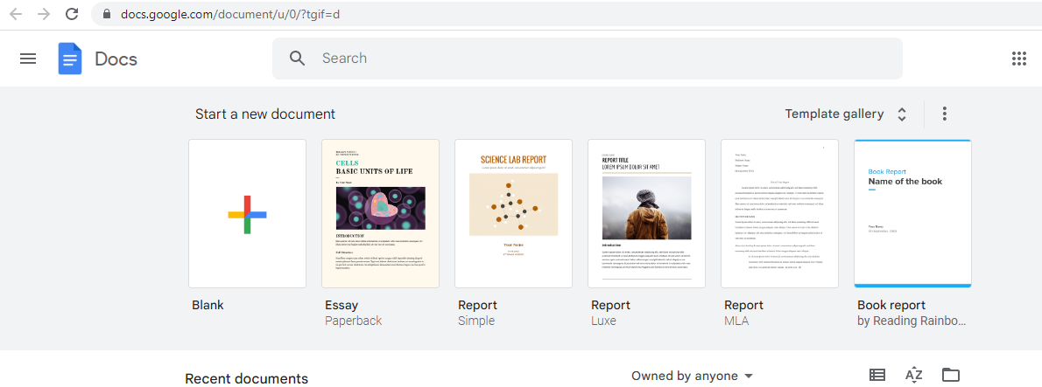

Step 2: Click on three lines which are to the left top corner

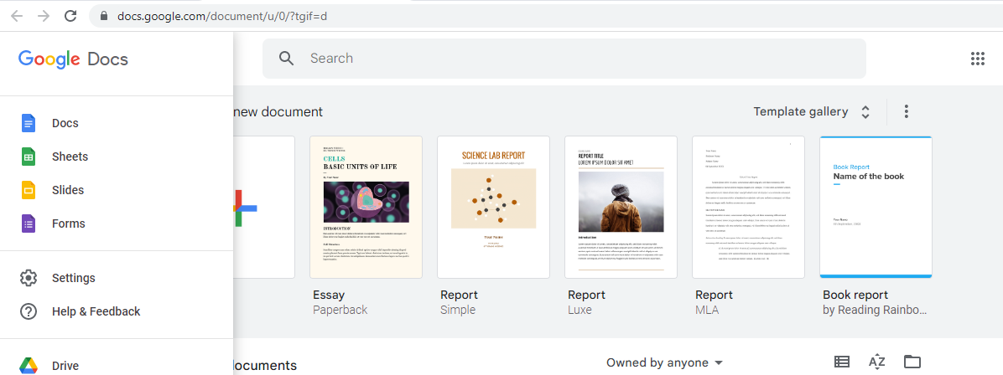

Step 3: Edit one Slide Online with Google Slides

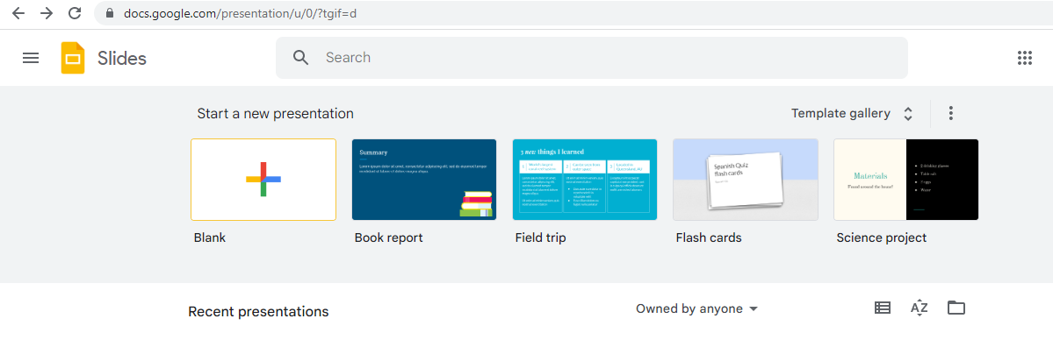

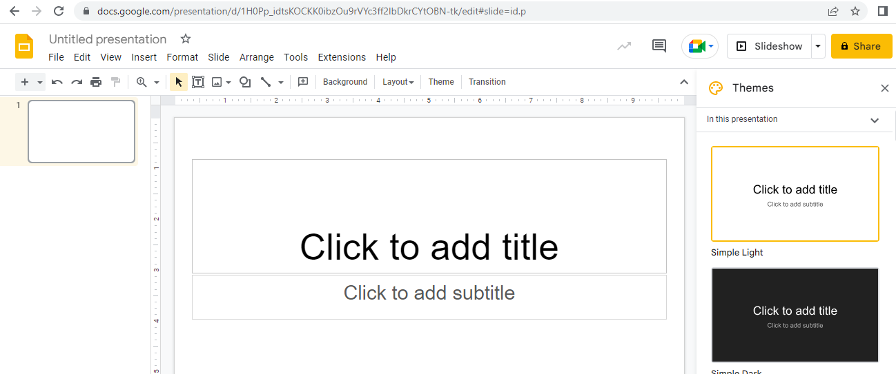

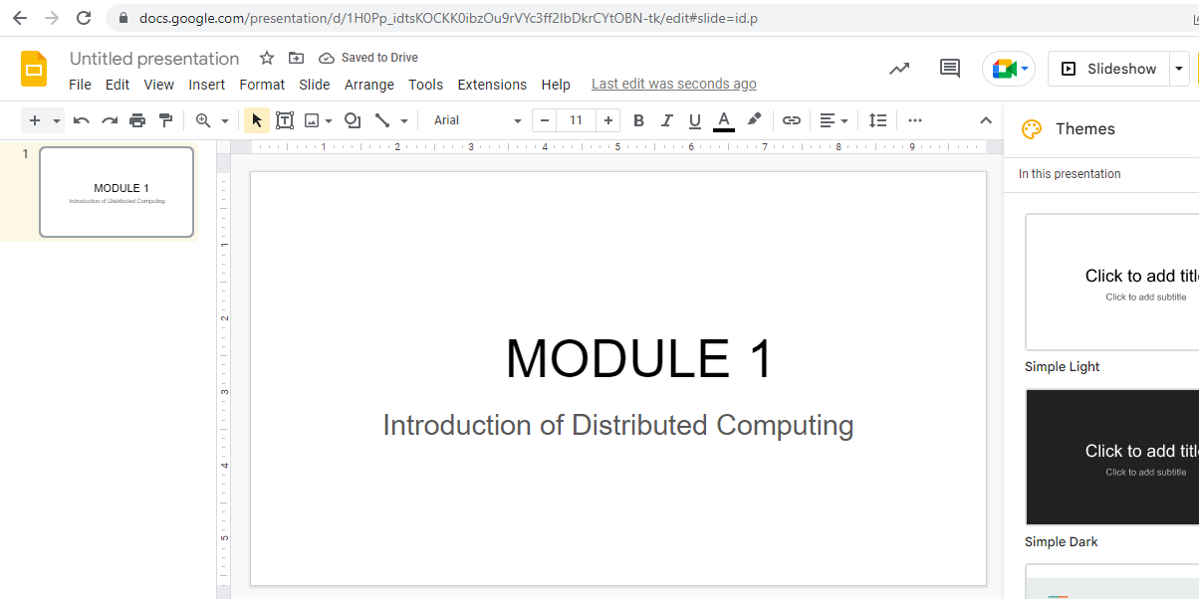

**Conclusion:**

Google Docs provide an efficient way for storage of data. It fits well in Storage as a service (STaaS). It has varied options to create documents, presentations and also spreadsheets. It saves documents automatically after a few seconds and can be shared anywhere on the Internet at the click of a button.